REG NO: 21TD0005 NAME: AKASH L YEAR/SEM/SEC: Y3/S5/B

FIRST COME FIRST SERVE SCHEDULING

SOURCE CODE:
#include<stdio.h>
#include<conio.h>
void main()
{
int n,i,a[20],b[20],c[20],t=0,tt=0,wt=0;
float awt,att;
clrscr();
printf("\nFIRST COME FIRST SERVE SCHEDULING\n");
printf("\nEnter the Number of Processes : ");
scanf("%d",&n);
for(i=0;i<n;i++)
{
printf("\nEnter the Burst - Time of Process %d : ",i+1);
scanf("%d",&a[i]);
}
for(i=0;i<n;i++)
{
c[i]=t;
t=t+a[i];

b[i]=t;
}
printf("\n\nPROCESS\tBURST TIME\tWAITING TIME\tTURN AROUND TIME\n");
for(i=0;i<n;i++)
printf("\nP%d\t\t%d\t\t%d\t\t%d",i+1,a[i],c[i],b[i]);
for(i=0;i<n;i++)
tt=tt+b[i];
for(i=0;i<n;i++)
wt=wt+c[i];
awt=wt/n;
printf("\n\nThe Average Waiting Time : %f ms",awt);
att=tt/n;
printf("\n\nThe Average Turn Around Time : %f ms\n\n",att);
printf("\n\t\tGANTT CHART\n\n");
for(i=0;i<n;i++)
printf("\tP%d",i+1);
printf("\n--------------------------------------------\n");
printf("0");
for(i=0;i<n;i++)
printf("\t%d",b[i]);
printf("\n--------------------------------------------\n");
getch();
}

OUTPUT:
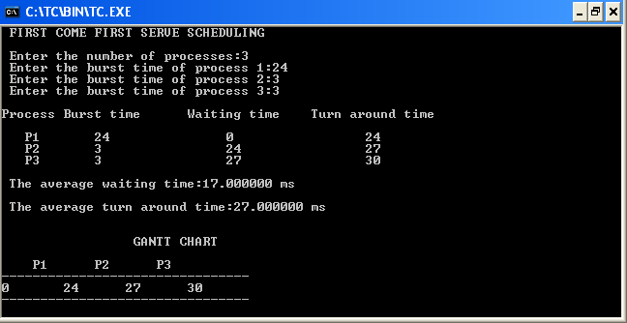

REG NO: 21TD0005 NAME: AKASH L YEAR/SEM/SEC: Y3/S5/B

SHORTEST JOB FIRST SCHEDULING

SOURCE CODE:
#include<stdio.h>
#include<conio.h>
void main()
{
int wt,j,c[10],p[10],i,tt,n,t1,t2,t3,a[10],ch;
float awt=0.0,avg=0.0,s,t;
clrscr();
printf("\t\tSHORTEST JOB FIRST SCHEDULING\n\n");
printf("Enter the Number of Processes : ");
scanf("%d",&n);
for(i=1;i<=n;i++)
{
printf("\nEnter the Burst-Time for Process %d : ",i);
scanf("%d",&c[i]);
a[i]=c[i];
}
for(i=1;i<=n;i++)
for(j=i+1;j<=n;j++)
if(c[i]>c[j])
{

t1=c[i];
c[i]=c[j];
c[j]=t1;
}
i=1;j=1;c[0]=0;
while(i<=n)
{
if(c[i]==a[j]&&ch!=j)
{
p[i]=j;
ch=j;
i++;
j=0;
}
j++;
}
wt=0;c[0]=0;tt=0;
printf("\n\nPROCESS\tBURST TIME\tWAITING TIME\tTURN AROUND TIME\n");
for(i=0;i<=n-1;i++)
{
wt=wt+c[i];
tt=tt+c[i+1];
printf("\nP%d\t\t%d\t\t%d\t\t%d\n",p[i+1],c[i+1],wt,tt);
awt=awt+wt;

avg=avg+tt;
}
s=awt/n;
t=avg/n;
printf("\n\nThe Average Waiting Time : %f ms",s);
printf("\nThe Average Turn Around Time : %f ms",t);
printf("\n\n\n\t\tGANTT CHART\n");
printf("\n-------------------------------------------------------\n");
wt=0;
for(i=1;i<=n;i++)
printf("\tP%d\t",p[i]);
printf("\n-------------------------------------------------------\n");
printf("0\t");
for(i=1;i<=n;i++)
{
wt=wt+c[i];
printf("%d\t\t",wt);
}
getch();
}

OUTPUT:

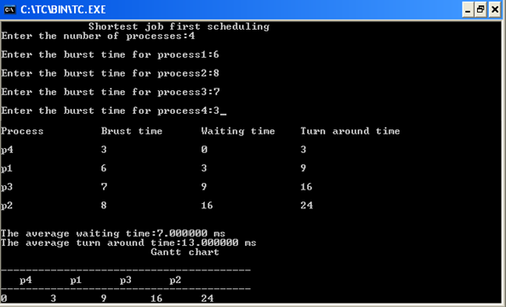

REG NO: 21TD0005 NAME: AKASH L YEAR/SEM/SEC: Y3/S5/B

PRIORITY SCHEDULING

SOURCE CODE:

#include<stdio.h>
#include<conio.h>
void main()
{
int i,j,n,p[10],c[10],wt,tt,t1,t2,b[10],pro[10],tp,b1[10],ch,tb;
float awt=0.0,s=0.0,avg=0.0,t=0.0;
printf("\t\tPRIORITY SCHEDULING\n");
printf("\nEnter the number of processes:");
scanf("%d",&n);
for(i=1;i<=n;i++)
{
printf("\nPROCESS%d: \nPRIORITY:",i);
scanf("%d",&p[i]);
printf("\nBURST TIME:");
scanf("%d",&c[i]);
b[i]=p[i];
b1[i]=p[i];
}
for(i=1;i<=n;i++)
for(j=i+1;j<=n;j++)
if(p[i]>p[j])
{
t1=c[i];
c[i]=c[j];
c[j]=t1;
t2=p[i];
p[i]=p[j];
p[j]=t2;
tp=pro[i];
pro[i]=pro[j];
pro[j]=tp;
tb=b[i];
b[i]=b[j];
b[j]=tb;
}
i=1;j=1;
while(i<=n)
{
if(p[i]==b1[j]&&ch!=j)
{
p[i]=j;
pro[i]=j;
ch=j;
i++;
j=0;
}
j++;
}
wt=0;c[0]=0;tt=0;
printf("\n\nPROCESS\tBURST TIME\tWAITING TIME\tTURN AROUND TIME\n");
for(i=0;i<n;i++)
{
wt=wt+c[i];
tt=tt+c[i+1];
printf("\n\nP%d\t\t%d\t\t%d\t\t%d\t\t%d\n",pro[i+1],b[i+1],c[i+1],wt,tt);
awt=awt+wt;
avg=avg+tt;
}
s=awt/n;
t=avg/n;
printf("\n\nTHE AVERAGE WAITING TIME:%f ms",s);
printf("\n\nTHE AVERAGE TURN AROUND TIME:%f ms",t);
printf("\n\n\t\tGANTT CHART \n\n");
wt=0;
printf("\n------------------------------------\n");
printf("0");
for(i=0;i<=n;i++)
{
wt=wt+c[i];
printf("%d\t",wt);
}
}

OUTPUT:

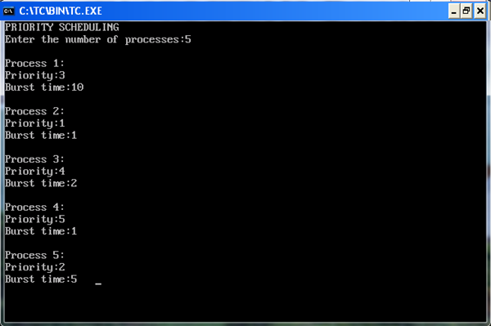
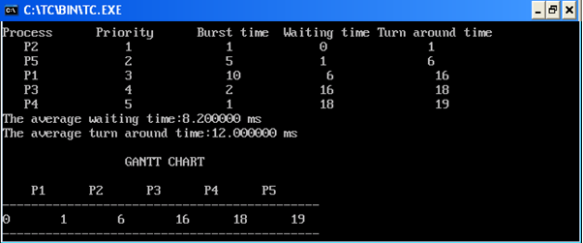

REG NO: 21TD0005 NAME: AKASH L YEAR/SEM/SEC: Y3/S5/B

ROUND ROBIN SCHEDULING

SOURCE CODE:
#include<stdio.h>
#include<conio.h>
void main()
{
int i,z=1,z1,n,n1,awt,p[10],j[10],t[10],t1[10],b[10],w[10],b1[10],b2[10];
int temp[10],m=0,ts;
float aw=0.0,at=0.0;
printf("\n\t\t ROUND ROBIN SCHEDULING\n");
printf("\n enter the number of processes:");
scanf("%d",&n);
n1=n;
printf("\n enter the time slice:");
scanf("%d",&ts);
for(i=1;i<=n;i++) {
printf("\n enter the burst time for p%d:",i);
scanf("%d",&b[i]);
b1[i]=b2[i]=b[i];p[i]=i;temp[i]=0;w[i]=0;t[i]=0;
}
printf("\n\n\t\t GANTT CHART\n");
printf("\n--------------------------------------------------\n");
while(n1!=0)
{
for(i=1;i<=n;i++)
if(b1[i]>ts)
{
m=m+ts;
t1[z]=m;
b1[i]=b1[i]-ts;
printf("\t p%d",p[i]);
temp[i]++;
z++;
}
else if(b1[i]!=0)
{
n1--;
w[i]=m-temp[i]*ts;
printf("\t p%d",p[i]);
aw+=w[i];m+=b1[i];t1[z]=m;t[i]=m;
at=at+t[i];b1[i]=0;z++;
}
}
printf("\n-----------------------------------------------------\n");
z1=z;
printf("\n0");
for(i=1;i<z1;i++)
printf("\t %d",t1[i]);
printf("\n------------------------------------------------------\n");
printf("\n\n PROCESS\t BURST TIME\t WAITING TIME\tTURN AROUND TIME\n");
for(i=1;i<=n;i++)
printf("p%d\t\t%d\t\t%d\t\t%d\t\t\n",p[i],b[i],w[i],t[i]);
at/=n;
aw/=n;
printf("\n the average waiting time:%fms",aw);
printf("\n the average turn around time:%fms",at);
getch();
}
OUTPUT:
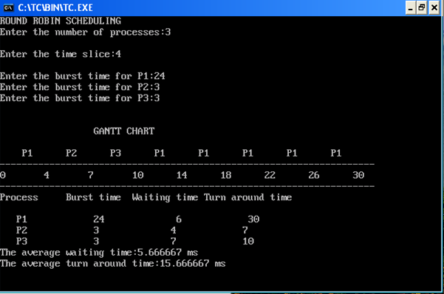

REG NO: 21TD0005 NAME: AKASH L YEAR/SEM/SEC: Y3/S5/B

PRODUCER CONSUMER PROBLEM

SOURCE CODE:
#include<stdio.h>
#include<conio.h>
#include<stdlib.h>
int product,counter=0,b,ch,buffer[100],in=0,out=0;
void producer();
void consumer();
void main()
{
printf("\nPRODUCER CONSUMER PROBLEM\n");
printf("\nEnter the Buffer size...:");
scanf("%d",&b);
while(ch!=3)
{
printf("\nMenu\n1.Product\n2.Consumer\n3.Exit\n");
printf("\nEnter your choice..:");
scanf("%d",&ch);
switch(ch)
{
case 1:
producer();
break;
case 2:
consumer();
break;
case 3:
exit(0);
break;
default:
printf("wrong entry");
}
}
}
void producer()
{
while(counter==b)
{
printf("\nBuffer Full....");
return;
}
printf("\nEnter Product Id..:");
scanf("%d",&product);
buffer[in]=product;
in=(in+1)%b;
counter++;
}
void consumer()
{
while(counter==0)
{
printf("\nBuffer Empty...");
return;
}
product=buffer[out];
printf("\nConsumer Consumed %d Product",product);
out=(out+1)%b;
counter--;
}

OUTPUT

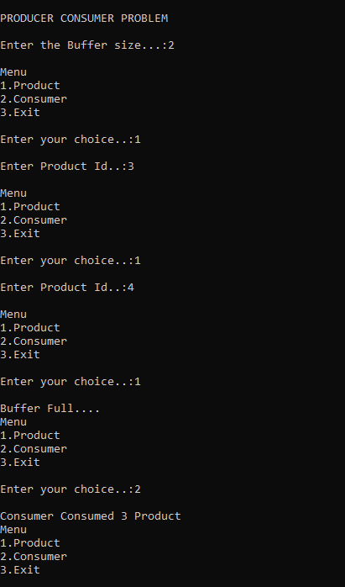

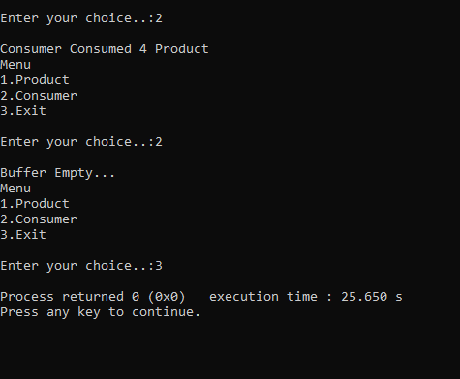

REG NO: 21TD0005 NAME: AKASH L YEAR/SEM/SEC: Y3/S5/B

READER WRITER PROBLEM

SOURCE CODE:
#include<stdio.h>
#include<conio.h>
void main()
{
int p[20],s[20],i,no,flag,rd[20],count;
printf("\nREADER-WRITER PROBLEM\n");
printf("\nEnter the process Number..");
scanf("%d",&no);
printf("--------------------------------------------");
printf("\n\t0---READING");
printf("\n\t1---WRITING");
printf("\n--------------------------------------------");
for(i=1;i<=no;i++)
{
printf("\nValue of process Id...");
scanf("%d",&p[i]);
printf("\nStatus of Process Id...");
scanf("%d",&s[i]);
}
printf("\nProcess Id\tStatus");
for(i=1;i<=no;i++)
{
printf("\n%d\t\t%d",p[i],s[i]);
}
printf("\n\n\nWriters list");
flag=0;
for(i=1;i<=no;i++)
{
if(s[i]==1)
{
flag=1;
printf("\nProcess Id %d",p[i]);
count++;
while(count!=0)
{
count--;
}
}
else
{
rd[i]=p[i];
}
}
if(flag==1)
printf("\nWriting is completed");
else
printf("\nno Writing Process");
printf("\n\n\nReaders List");
flag=0;
for(i=1;i<=no;i++)
{
if(s[i]!=1)
{
flag=1;
printf("\nProcess Id=%d",rd[i]);
}
}
if(flag==0)
{
printf("\nNo Reading Process");
}
}

OUTPUT:
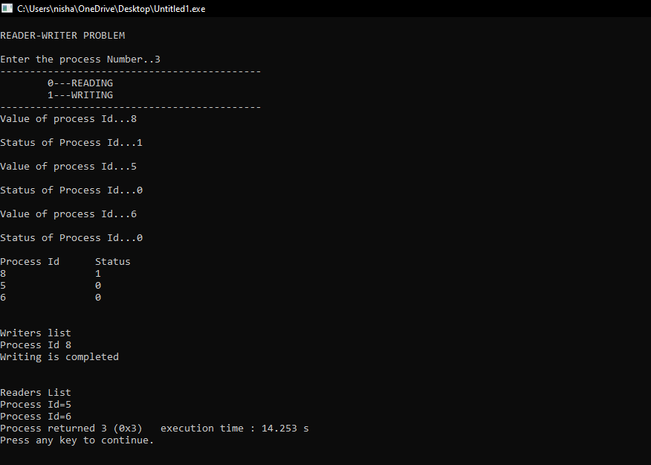

REG NO: 21TD0005 NAME: AKASH L YEAR/SEM/SEC: Y3/S5/B

DINING PHILOSOPHER PROBLEM

SOURCE CODE:
#include<stdio.h>
#include<conio.h>
int st[25],temp[25];
void eating(int,int,int);
void main()
{
int n=5,f,i,x,y;
int ch;
printf("\n\t\tDINING-PHILOSPER PROBLEM");
xx:
printf("\nASSUMPTION\n");
printf("\nHUNGRY==>1\nEATING==>2\nTHINKING==>3\n");
for(i=1;i<=n;i++)
do {
f=0;
printf("\nEnter the status of %d :",i);
scanf("%d",&st[i]);
if(st[i]>3||(st[i]<1))
{
printf("\nEntered philosopher ststus is invalid");
printf("\nDo you want to try again(Y/N):");
ch=getch();
if(ch=='y'||ch=='Y')
f=1;
else
{
f=0;
printf("\nSTOP");
getch();
exit(1);
}
}
}
while(f==1);
for(i=1;i<=n;i++)
{
if(i==n)
{
x=n;
y=1;
}
else
{
x=i;
y=i+1;
}
if((st[x]==2)&&(st[y]==2))
{
printf("\nEntered philosopher stsus id invalid");
printf("\nSorry try again...");
goto xx;
}
}
printf("\n\nRESULTS....:");
for(i=1;i<=n;i++)
{
if(st[i]==3)
printf("\nPhilosopher %d is thinking\n",i);
if(st[i]==2)
printf("\nPhilosopher %d id eating\n",i);
if(st[i]==1)
{
if(i==1)
eating(i+1,i+4,i);
else eating(i+1,i-1,i);
}
}
}
void eating(int x,inty,int z)
{
if(temp[x]==1)
{
printf("\nPhilosopher %d is hungry and cannot eat since %d has the possibility of eating\n",x,z);
return;
}
if(temp[y]==1)
{
printf("\nPhilosopher %d is hungry and cannot eat since %d has the possibility of eating\n",z,y);
return;
}
if((st[x]!=2)&&(st[y]!=2))
{
printf("\n\nPhilosopher %d is hungry and cannot eat\n",z);
st[z]=2;
temp[z]=1;
}
if((st[x]==2)&&(st[y]==2))
{
printf("\n\nPhilosopher %d is hungry but not eatting since neighbours %d, %d are eating\n",z,x,y);
return;
}
if(st[x]==2)
{
printf("\n\nPhilosopher %d is hungry but not eating since neighbours %d, \n",z,x);
return;
}
if(st[y]==2)
{
printf("\n\nPhilosopher %d is hungry but not eating since neighbours %d, \n",z,y);
return;
}
}

OUTPUT:
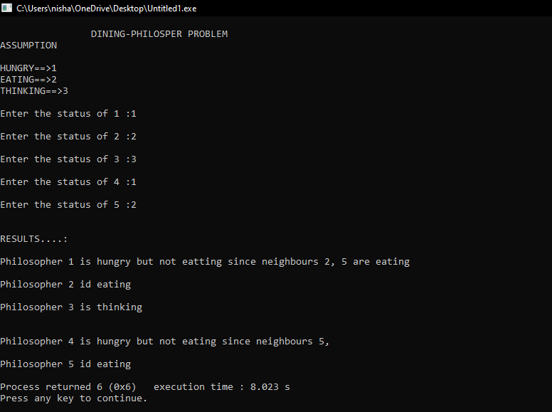

REG NO: 21TD0005 NAME: AKASH L YEAR/SEM/SEC: Y3/S5/B

CONTIGUOUS MEMORY ALLOCATION

SOURCE CODE:
#include<stdio.h>
#include<stdlib.h>
int i,n;
struct f
{
int nm,r;
}
h[25];
int fit()
{
printf("\n enter the total no.of blocks and holes:");
scanf("%d",&n);
for(i=1;i<=n;i++)
{
xx:
printf("\n enter whether it is block or holes:");
scanf("%d",&h[i].nm);
if((h[i].nm!=1)&&(h[i].nm!=2))
{
printf("\n enter the name is invalid try again");
goto xx;
}
printf("\n enter the size:");
scanf("%d",&h[i].r);
}
return 0;
}
int ffit(int x)
{
for(i=0;i<=n;i++)
{
if((h[i].nm==2)&&(x<=h[i].r))
{
printf("\n allocation of block %d by first fit:",x);
printf("%d",h[i].r);
break;
}
}
if(i==n+1)
printf("\n first fit:");
return 0;
}
int wfit(int x)
{
int t=0;
for(i=0;i<=n;i++)
{
if((h[i].nm==2)&&(x<=h[i].r)&&(t<h[i].r))
t=h[i].r;
}
printf("\n allocation of block %d by worst fit:",x);
printf("%d",t);
return 0;
}
int bfit(int x)
{
int temp[25],k=1;
for(i=1;i<=n;i++)
{
if((h[i].nm==2)&&(x<=h[i].r))
{
temp[k]=h[i].r;
k++;
}
}
for(i=1;i<k;i++)
{
int j;
for(j=i+1;j<k;j++)
{
if(temp[i]>temp[j])
{
int t=temp[i];
temp[i]=temp[j];
temp[j]=t;
}
}
}
printf("\n allocation of bloack %d by best fit:",x);
printf("%d",temp[1]);
return 0;
}
int show()
{
printf("\n allocation of block and holes \n");
for(i=1;i<=n;i++)
{
if(h[i].nm==1)
{
printf("block(%d)\n",h[i].r);
}
else
{
printf("hole(%d)\n",h[i].r);
}
}
return 0;
}
int main()
{
int b;
printf("\n block =1\n");
printf("\n hole=2\n");
fit();
show();
printf("\n enter the block to be inserted:");
scanf("%d",&b);
ffit(b);
bfit(b);
wfit(b);
return 0;
}

OUTPUT:
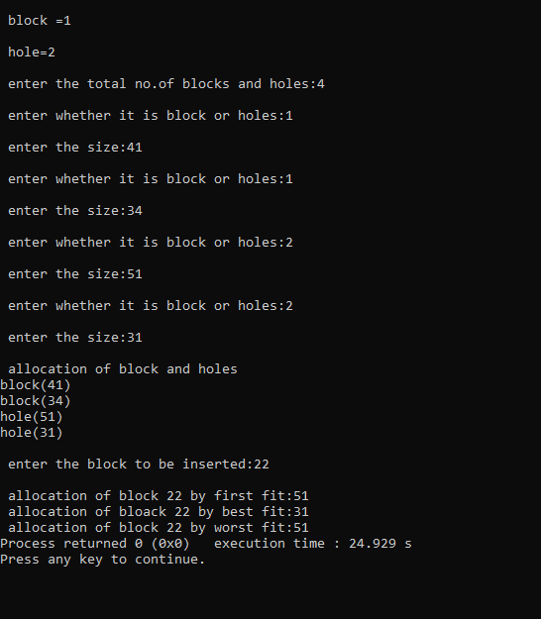

REG NO: 21TD0005 NAME: AKASH L YEAR/SEM/SEC: Y3/S5/B

SIMULATION OF PAGING

SOURCE CODE:
#include<stdio.h>
#include<conio.h>
void main()
{
int phyadr,psi,frame,page,offset,n,pt[20],logadr,i;
clrscr();
printf("\nSIMULATION OF PAGING");
printf("\n\nEnter the Number of Pages...: ");
scanf("%d",&n);
printf("\n\nEnter the Page Size..: ");
scanf("%d",&psi);
printf("\n\nEnter the Page Table Values...");
printf("\n\nPage Number\tValue");
for(i=0;i<n;i++)
{
printf("\n%d\t\t",i);
scanf("%d",&pt[i]); }
printf("\n\nEnter the Logical Address..: ");
scanf("%d",&logadr);
if(logadr>(n*psi)-1)
printf("\nInvalid address...");
else {
offset=logadr%psi;
page=logadr%psi;
phyadr=(psi*pt[page]+offset);
printf("\n\nPhysical Address = (%d * %d) + %d",psi,pt[page],offset);
printf("\n\nPhysical Address is %d",phyadr);
}
getch();
}

OUTPUT:
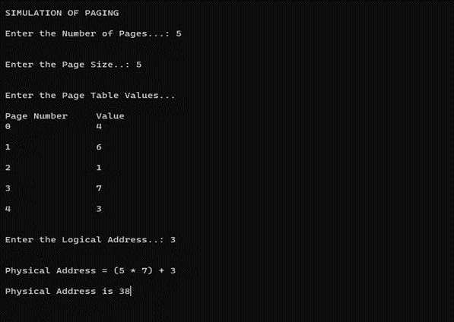

REG NO: 21TD0005 NAME: AKASH L YEAR/SEM/SEC: Y3/S5/B

SIMULATION OF SEGMENTATION

SOURCE CODE:
#include<stdio.h>
#include<conio.h>
int main()
{
int n,x,y,sc,pa,ba,ab,li,b[10],l[10],i[10],j;
y=y-1;
printf("\n\t\tSIMULATION OF SEGMENTATION\n");
printf("\nEnter the Number of Entries : ");
scanf("%d",&n);
for(x=0;x<n;x++)
{
printf("SEGMENT NO:");
scanf("%d",&i[x]);
printf("LIMIT:");
scanf("%d",&l[x]);
printf("BASE:");
scanf("%d",&b[x]);
}
printf("\nEnter the Segment No.: ");
scanf("%d",&sc);
for(j=0;j<n;j++)
if(i[j]==sc)
{
y=1;
ba=b[j];
li=l[j];
}
if(y<0)
{
printf("\nINVALID SEGMENT\n");
}
printf("\nEnter the Byte to be Referenced : ");
scanf("%d",&ab);
if(ab>li)
{
printf("\nCannot Find this Address :");
printf("\nLimit Only %d",i);
}
pa=ba+ab;
printf("\nThe Physical Address is : ");
printf("%d\n",pa);
getch( );
}

OUTPUT:
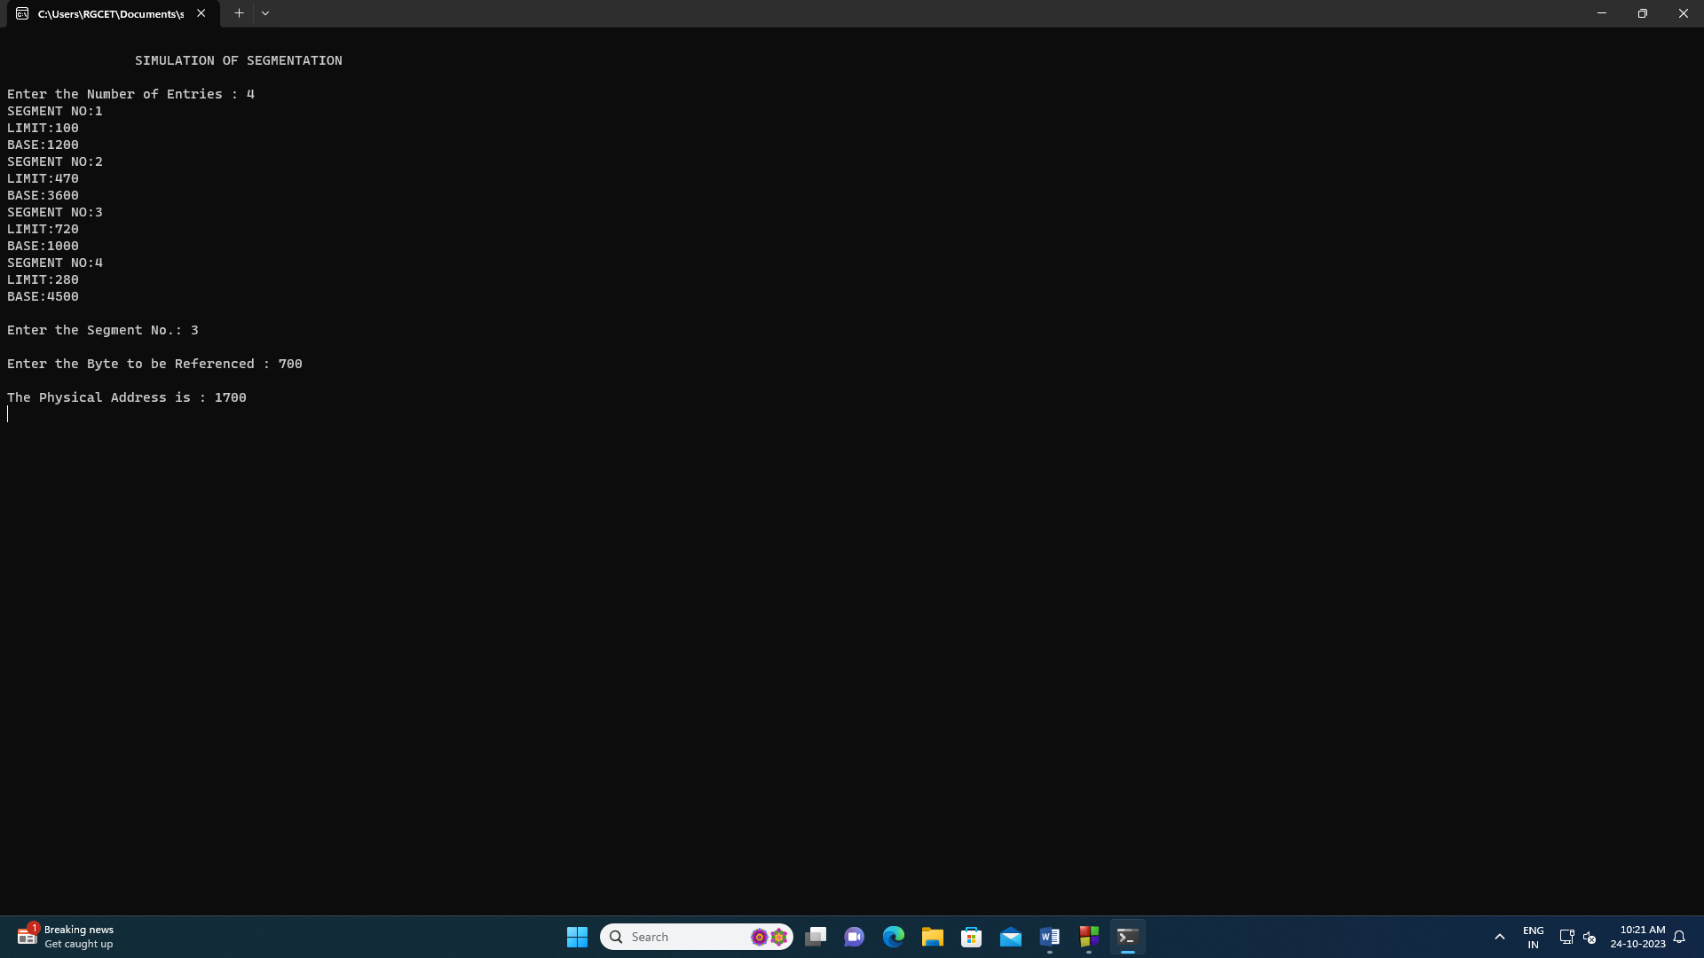

REG NO: 21TD0005 NAME: AKASH L YEAR/SEM/SEC: Y3/S5/B

FIFO PAGE REPLACEMENT

SOURCE CODE:
#include<stdio.h>
#include<stdlib.h>
void main()
{
int i,j,a[50],frame[10],n,no,k,avail,count=0;
printf("\n***FIFO PAGE REPLACEMENT ***");
printf("\n Enter the number of reference string:\n");
scanf("%d",&n);
printf("Enter the page number:\n");
for(i=1;i<=n;i++)
scanf("%d",&a[i]);
printf("\nEnter the number of frames:");
scanf("%d",&no);
for(i=0;i<=no;i++)
frame[i]=-1;
j=0;
printf("\n Ref string\tpage frame\n");
for(i=1;i<=n;i++)
{
printf("%d\t\t",a[i]);
avail=0;
for(k=0;k<=no;k++)
if(frame[k]==a[i])
avail=1;
if(avail==0)
{
frame[j]=a[i];
j=(j+1)%no;
count++;
for(k=0;k<no;k++)
printf("%d\t",frame[k]);
}
printf("\n");
}
printf("\n page fault is %d",count);
getch ();
}

OUTPUT:
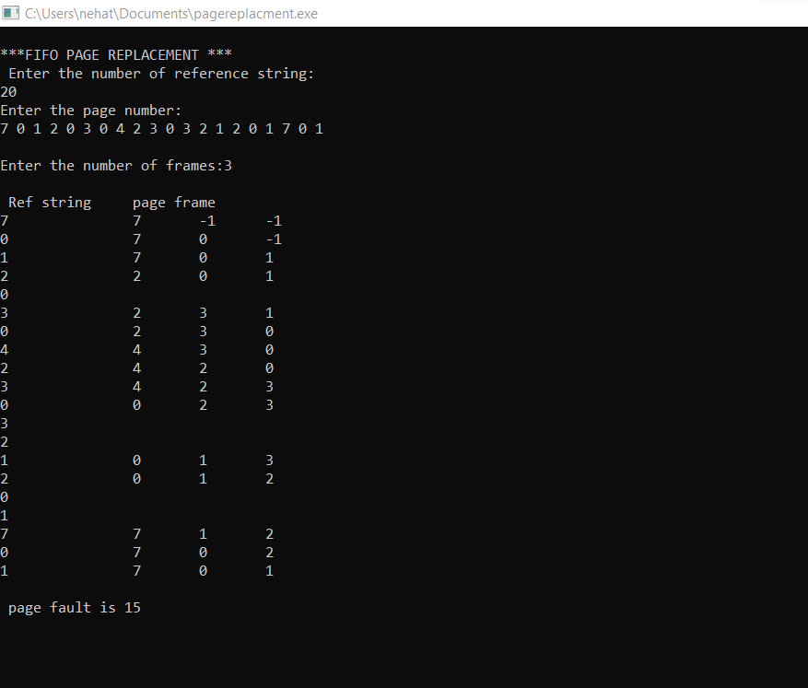

REG NO: 21TD0005 NAME: AKASH L YEAR/SEM/SEC: Y3/S5/B

LRU PAGE REPLACEMENT

SOURCE CODE:
#include<stdio.h>
void main()
{
int q[20],p[50],c=0,c1,f,i,j,k=0,n,r,t,b[20],c2[20];
printf("\n\t\t***LRU-PAGE REPLACEMENT***\n");
printf("\nEnter the no. of pages:");
scanf("%d",&n);
printf("\nEnter the reference string:");
for(i=0;i<n;i++)
scanf("%d",&p[i]);
printf("\nEnter the no. of frames:");
scanf("%d",&f);
printf("\nReference string\t \tpage frames");
q[k]=p[k];
printf("\n%d",p[k]);
printf("\t%d",q[k]);
c++;
k++;
for(i=1;i<n;i++)
{
printf("\n%d",p[i]);
c1=0;
for(j=0;j<f;j++)
{
if(p[i]!=q[j]) c1++;
}
if(c1==f)
{
c++;
if(k<f)
{
q[k]=p[i];
k++;
for(j=0;j<k;j++)
printf("\t%d",q[j]);
}
else
{
for(r=0;r<f;r++)
{
c2[r]=0;
for(j=i-1;j<n;j--)
{
if(q[r]!=p[j])
c2[r]++;
else
break;
}
}
for(r=0;r<f;r++)
b[r]=c2[r];
for(r=0;r<f;r++)
b[r]=c2[r];
for(r=0;r<f;r++)
{
for(j=r;j<f;j++)
{
if(b[r]<b[j])
{
t=b[r];
b[r]=b[j];
b[j]=t;
}
}
}
for(r=0;r<f;r++) {
if(c2[r]==b[0])
q[r]=p[i];
printf("\t%d",q[r]);
}
}
}
}
printf("\nThe no. of page faults is %d",c);
getch ();
}

OUTPUT:
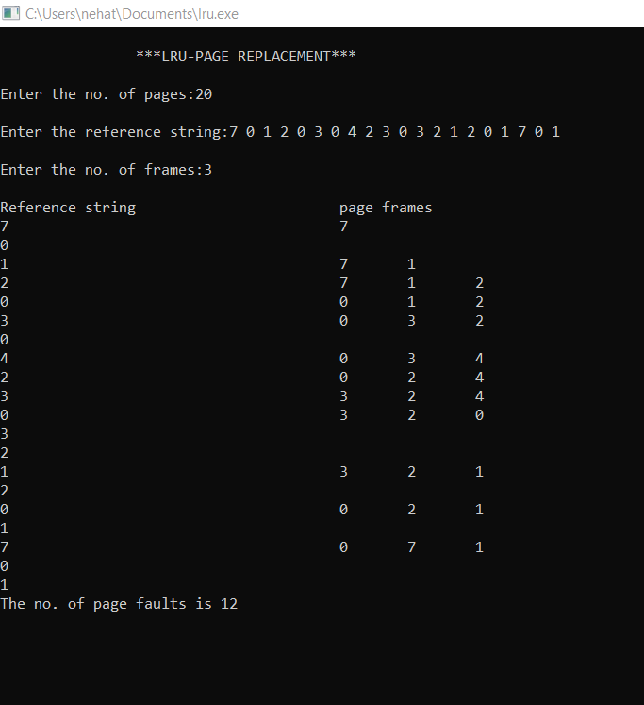

REG NO: 21TD0005 NAME: AKASH L YEAR/SEM/SEC: Y3/S5/B

OPTIMAL PAGE REPLACEMENT
SOURCE CODE:
#include<stdio.h>
#include<conio.h>
#define max 25
void main()
{
int frame[10],length[10],index,highest;
int i,j,k,n,nf,page[max],temp;
int flag=0,pf=0,found=0;
printf("\n\toptimal PAGE REPLACEMENT\n");
printf("\nEnter no. of frames:");
scanf("%d",&nf);
for(i=0;i<nf;i++)
frame[i]=-1;
printf("\nEnter the no. of ref string:");
scanf("%d",&n);
printf("\nEnter the ref string:");
for(i=0;i<n;i++)
{
scanf("%d",&page[i]);
}
printf("\n\tRef.String\tPage\t Frames\n");
for(i=0;i<n;i++)
{
flag=0;
for(j=0;j<nf;j++)
{
if(frame[j]==page[i])
{
printf("\n%d\t\t",page[i]);
flag=1;
break;
}
}
if(flag==0)
{
for(j=0;j<nf;j++)
{
for(temp=i+1;temp<n;temp++)
{
length[j]=0;
if(frame[j]==page[temp])
{
length[j]=temp-i;
break;
}
}
} found=0;
for(j=0;j<nf;j++)
{
if(length[j]==0)
{
index=j;
found=1;
break;
}
}
if(found==0)
{
highest=length[0];
index=0;
for(j=1;j<nf;j++)
{
if(highest<length[j])
{
highest=length[j];
index=j;
}
}
}
frame[index]=page[i];
printf("\n%d\t\t",page[i]);
pf++;
for(k=0;k<nf;k++)
printf("%d\t",frame[k]);
}
}
printf("\nNumber of page fault is:%d\n\n",pf);
getch ();
}
OUTPUT:
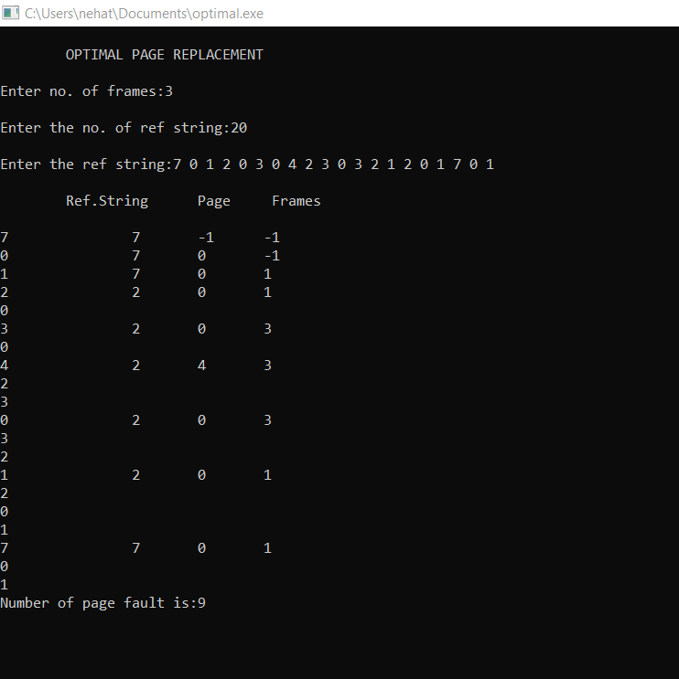

REG NO: 21TD0005 NAME: AKASH L YEAR/SEM/SEC: Y3/S5/B

CONTIGUOUS FILE ALLOCATION
SOURCE CODE:
#include<stdio.h>
#include<stdlib.h>
int main()
{
int i,j,b[20],sb[20],t[20],n,c[20][20],x;
clrscr();
printf("\t\t***CONTIGUOUS FILE ALLOCATION***\n");
printf("Enter the number of files:");
scanf("%d",&n);
for(i=0;i<n;i++)
{
printf("\nEnter the number of blocks occupied by %d:",i+1);
scanf("%d",&b[i]);
printf("\nEnter the starting block of file %d:",i+1);
scanf("%d",&sb[i]);
t[i]=sb[i];
for(j=0;j<b[i];j++)
c[i][j]=sb[i]++;
}
printf("\nFile name\tStart\tBlock Length\n");
for(i=0;i<n;i++)
printf("%d\t\t%d\t\t%d\n",i+1,t[i],b[i]);
printf("Enter the file name:");
scanf("%d",&x);
printf("\nFile name is %d",x);
printf("\nLength is %d",b[x-1]);
printf("\nBlocks Occupied..");
for(i=0;i<b[x-1];i++)
printf("\t%d",c[x-1][i]);
getch();
return 0;
}

OUTPUT:
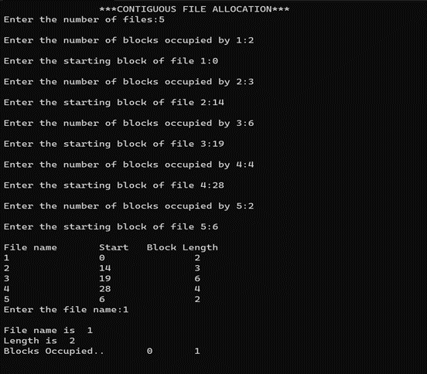
REG NO: 21TD0005 NAME: AKASH L YEAR/SEM/SEC: Y3/S5/B

LINKED FILE ALLOCATION
SOURCE CODE:
#include<stdio.h>
#include<conio.h>
struct fileno
{
char fname[10];
int start,size,block[10];
}
f[10];
int main()
{
int i,j,n;
printf("\n\t\tLINKED FILE ALLOCATION");
printf("\nEnter the no. of files:\n");
scanf("%d",&n);
for(i=0;i<n;i++)
{
printf("\nEnter the file name:");
scanf("%s",&f[i].fname);
printf("\nEnter the starting block:");
scanf("%d",&f[i].start);

f[i].block[0]=f[i].start;
printf("\nEnter the no. of blocks:");
scanf("%d",&f[i].size);
printf("\nEnter the block numbers:");
for(j=1;j<=f[i].size;j++)
{
scanf("%d",&f[i].block[j]);
}
}
printf("\nFile\tStart\tSize\tBlock\n");
for(i=0;i<n;i++)
{
printf("%s\t%d\t%d\t",f[i].fname,f[i].start,f[i].size);
for(j=0;j<=f[i].size-1;j++)
printf("%d-->",f[i].block[j]);
printf("%d(-1)",f[i].block[j]);
printf("\n");
}
getch();
return 0;
}

OUTPUT:
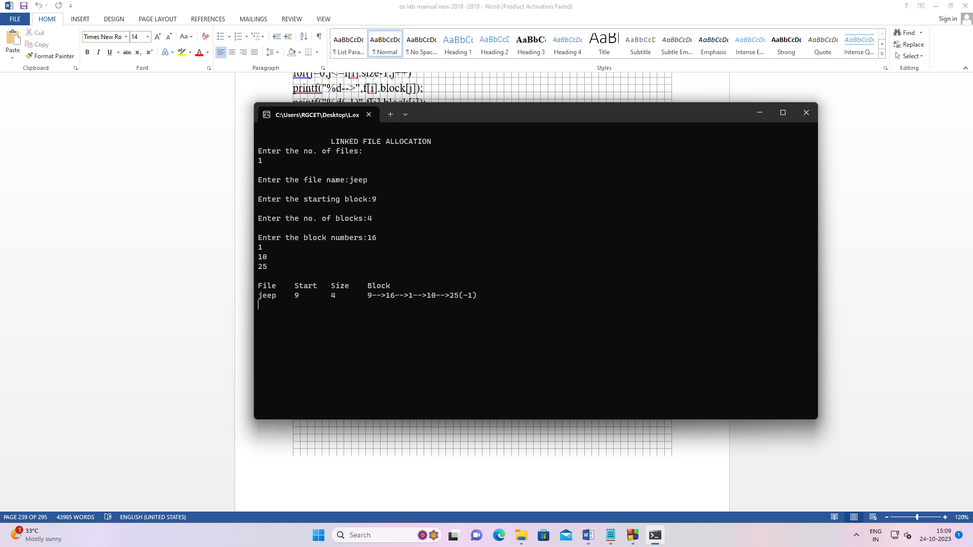

REG NO: 21TD0005 NAME: AKASH L YEAR/SEM/SEC: Y3/S5/B

INDEXED FILE ALLOCATION

SOURCE CODE:
#include<stdio.h>
#include<stdlib.h>
int main()
{
int n,m[20],i,j,sb[20],b[20][20],x;
printf("\t\t***INDEXED FILE ALLOCATION***");
printf("\nEnter no. of files:");
scanf("%d",&n);
for(i=0;i<n;i++)
{
printf("\nEnter index %d:",i+1);
scanf("%d",&sb[i]);
printf("\nEnter no. of blocks occupied by file %d:",i+1);
scanf("%d",&m[i]);
printf("\nEnter blocks of file %d:",i+1);
for(j=0;j<m[i];j++)
scanf("%d",&b[i][j]);
}
printf("\nFile\tIndex\tLength\n");
for(i=0;i<n;i++)
{
printf("%d\t%d\t%d\n",i+1,sb[i],m[i]);
}
printf("\nEnter file name:");
scanf("%d",&x);
printf("\nFile name is:%d",x);
i=x-1;
printf("\nIndex is:%d",sb[i]);
printf("\nBlocks occupied are:");
for(j=0;j<m[i];j++)
printf("\t%d",b[i][j]);
getch();
return 0;
}

OUTPUT:
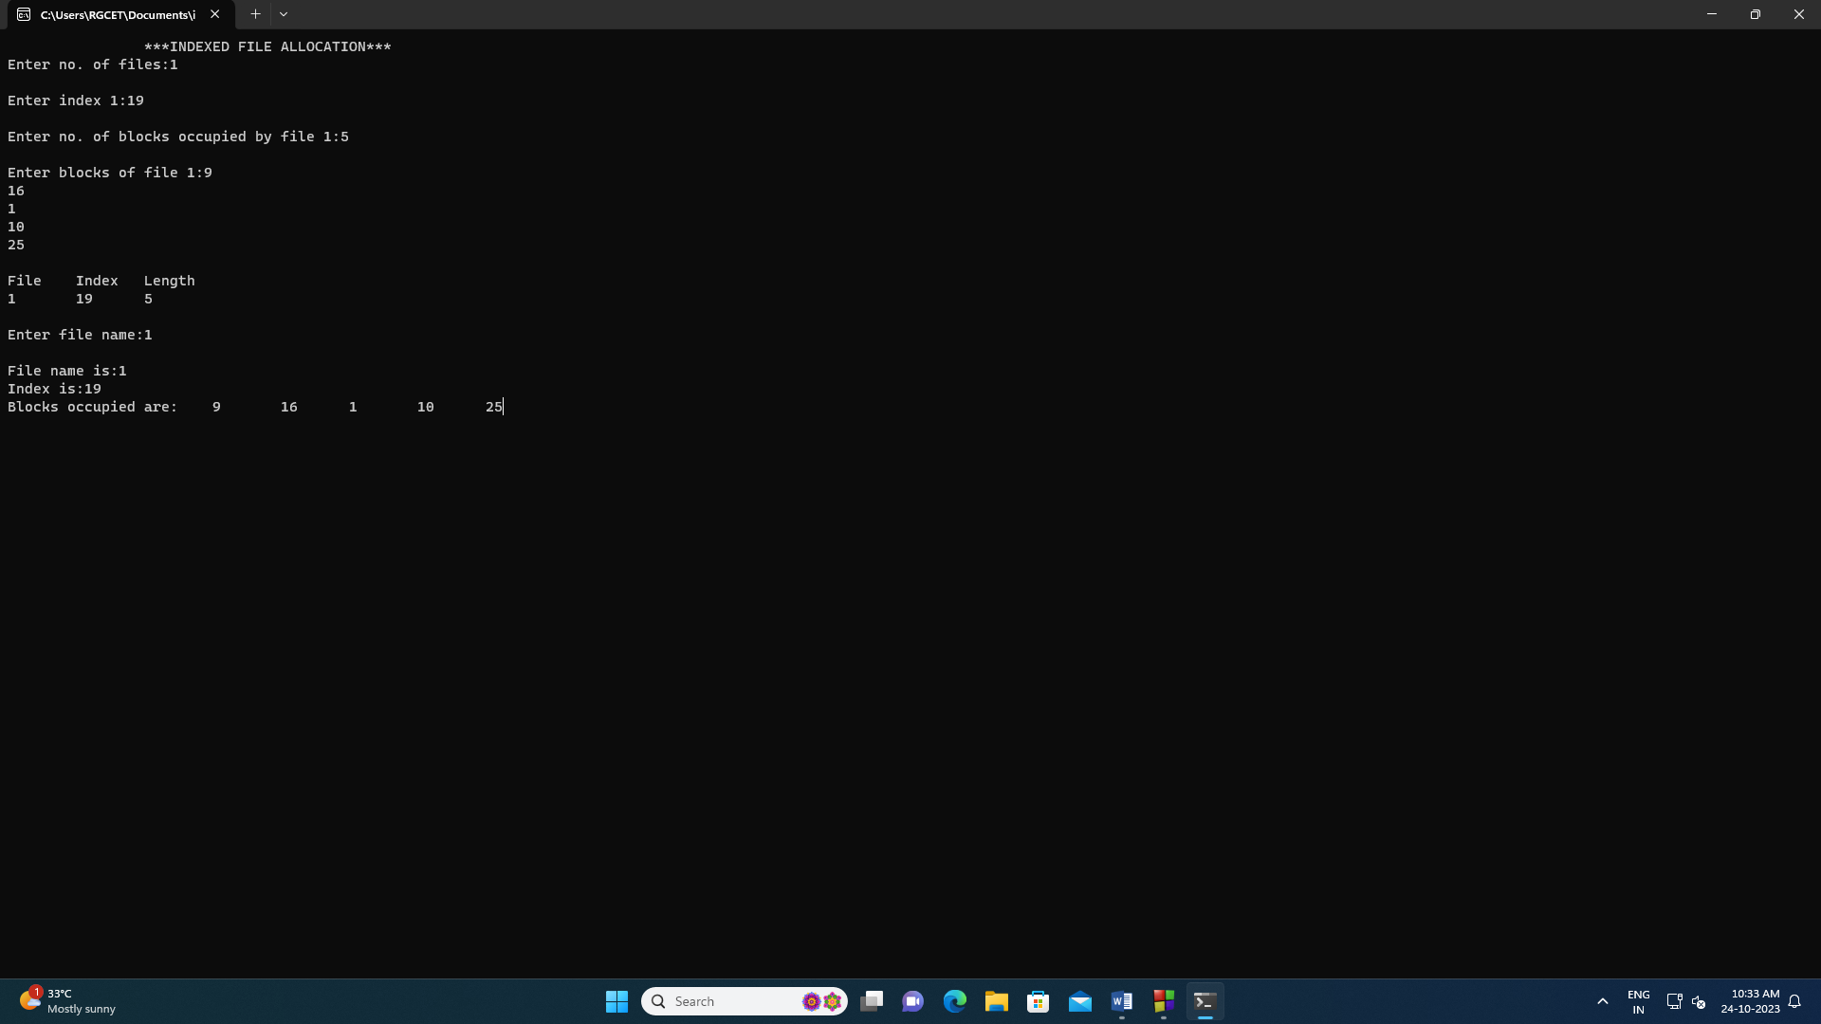

REG NO: 21TD0005 NAME: AKASH L YEAR/SEM/SEC: Y3/S5/B

FIRST COME FIRST SERVE SCHEDULING

SOURCE CODE:
#include<stdio.h>
#include<conio.h>
#include<stdlib.h>
#include<process.h>
int h,a[20],b=0,i,j,n;
void main( ) {
printf("FIRST COME FIRST SERVE DISK SCHEDULING\n");
printf("\nEnter the Number of Cylinder : ");
scanf("%d",&n);
printf("\nEnter the Cylinder Values : \n");
for(i=1;i<=n;i++)
scanf("%d",&a[i]);
printf("\nEnter the Starting Head Position : ");
scanf("%d",&h);
printf("\nThe Order of Visiting the Cylinders:\n");
for(i=1;i<=n;i++)
printf("\t%d",a[i]);
for(i=1;i<=n;i++) {
b+=abs(h-a[i]);
h=a[i];
}
printf("\nThe Seek Time is %d Cylinders",b);
getch( );
}
OUTPUT:

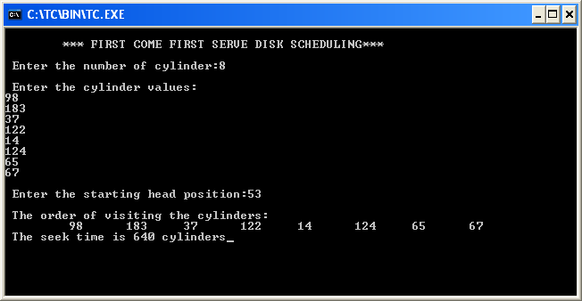

REG NO: 21TD0005 NAME: AKASH L YEAR/SEM/SEC: Y3/S5/B

SHORTEST SEEK TIME FIRST SCHEDULING

SOURCE CODE:
#include<stdio.h>
#include<conio.h>
#include<stdlib.h>
int sstf();
int seek=0,t1,t2,n,a[20]={{0}},z=1,d[20]={{0}},h=0;
void main()
{
int i,j,hr;
clrscr();
printf("\t\t SHORTEST SEEK TIME FIRST SCHEDULING \n\n");
printf("Enter the Number of Cylinders : ");
scanf("%d",&n);
printf("\nEnter the Cylinder Values : \n");
for(i=1;i<=n;i++)
scanf("%d",&a[i]);
printf("\nEnter the Starting Head Position : ");
scanf("%d",&h);
hr=h;
printf("\nThe Order of Visiting the Cylinders : \n");
for(i=1;i<=n;i++)
sstf();
printf("\n");
for(i=1;i<=n;i++)
{
seek=seek+abs(hr-d[i]);
hr=d[i];
}
printf("\nThe Seek Time is %d",seek);
getch();
}
int sstf()
{
int b[20]={{0}},c=1,i,j;
for(i=1;i<=n;i++)
b[i]=abs(h-a[i]);
for(i=1;i<=n;i++)
if(b[c]>b[i])
c=i;
printf("\t%d",a[c]);
h=a[c];
d[z]=a[c];
z++;
a[c]=9999;
return(0);
}

OUTPUT:
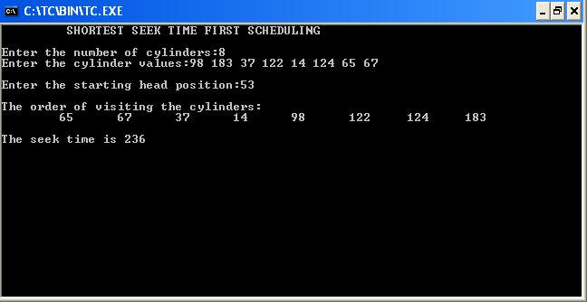

REG NO: 21TD0005 NAME: AKASH L YEAR/SEM/SEC: Y3/S5/B

SCAN SCHEDULING
SOURCE CODE:
#include<stdio.h>
#include<stdlib.h>
int main()
{
int hr,right=0,i,j,h,end,n,a[20],temp,post,left=0,start=0;
printf("\t\t**SCAN SCHEDULING**\n");
printf("\nEnter the ending position of disk:\n");
scanf("%d",&end);
printf("\nEnter the number of cylinders:\n");
scanf("%d",&n);
printf("\nEnter the cylinder value between 0 and %d...\n",end);
for(i=1;i<=n;i++)
{
scanf("%d",&a[i]);
}
for(i=1;i<=n;i++)
{
for(j=i+1;j<=n;j++)
{
if(a[i]>a[j])
{
temp=a[i];
a[i]=a[j];
a[j]=temp;
}
}
}
printf("\nEnter the head position:\n");
scanf("%d",&h);
hr=h;
for(i=1;i<=n;i++)
{
if(h<a[i])
break;
}
post=i;
printf("\nMoving in the right side:\n");
printf("\nThe order of visiting the cylinders:\n");
for(i=post;i<=n;i++)
{
right=right+abs(h-a[i]);
h=a[i];
printf("\t%d",h);
}
right=right+abs(h-end);
h=end;
for(i=post-1;i>=1;i--)
{
printf("\t%d",h);
right=right+abs(h-a[i]);
h=a[i];
}
printf("\t%d",h);
printf("\nThe seek time is:%d\n",right);
printf("\nMoving in the left side:\n");
printf("\nThe order of visiting the cylinder:\n");
for(i=post-1;i>=1;i--)
{
left=left+abs(hr-a[i]);
hr=a[i];
printf("\t%d",hr);
}
left=left+abs(hr-start);
hr=start;
for(i=post;i<=n;i++)
{
printf("\t%d",hr);
left=left+abs(hr-a[i]);
hr=a[i];
}
printf("\t%d",hr);
printf("\nThe seek time is:%d\n",left);
getch();
return 0;
}

OUTPUT:
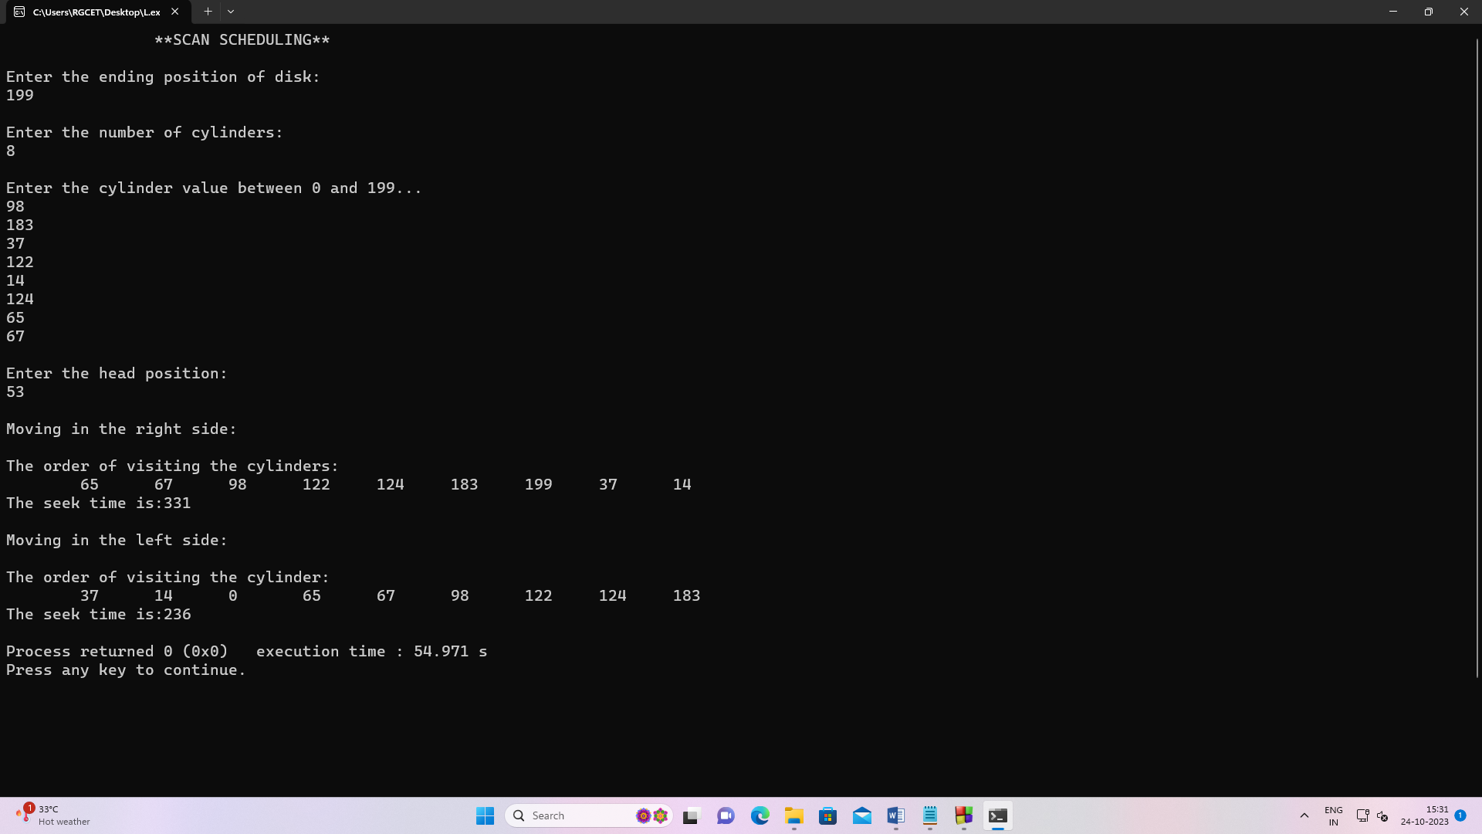

REG NO: 21TD0005 NAME: AKASH L YEAR/SEM/SEC: Y3/S5/B

C-SCAN SCHEDULING

SOURCE CODE:
#include<stdio.h>
#include<conio.h>
#include<stdlib.h>
void main( )
{
int left=0,hr,right=0,start=0,i,j,h,end,n,a[20],b[20],temp,post;
clrscr( );
printf(“ C – SCAN SCHEDULING “);
printf(“\n\nEnter the Ending Position of the Disc : “);
scanf(“%d”,&end);
printf(“\nEnter the Number of Cylinders : “);
scanf(“%d”,&n);
printf(“\nEnter the Cylinder Values between 0 and %d : \n”,end);
for(i=1;i<=n;i++)
scanf(“%d”,&a[i]);
for(i=1;i<=n;i++)
for(j=i+1;j<=n;j++)
if(a[i]>a[j])
{
temp=a[i];
a[i]=a[j];
a[j]=temp;
}
printf(“\nEnter the Starting Head Position : “);
scanf(“%d”,&h);
hr=h;
for(i=1;i<=n;i++)
{
if(h<a[i])
break;
}
post=i;
printf(“The Order of Visiting the Cylinders : \n”);
for(i=post;i<=n;i++)
{
right=right+abs(h-a[i]);
h=a[i];
printf(“\t%d”,h);
}
right=right+abs(h-end);
printf(“\t%d”,end);
right=right+abs(end-start);
h=start;
for(i=1;i<post;i++)
{
printf(“\t%d”,h);
right=right+abs(h-a[i]);
h=a[i];
}
printf(“\t%d”,h);
printf(“\nThe Seek Time is : %d\n\n”,right);
getch( );
}

OUTPUT:
